SPONSORSHIP PACKAGE
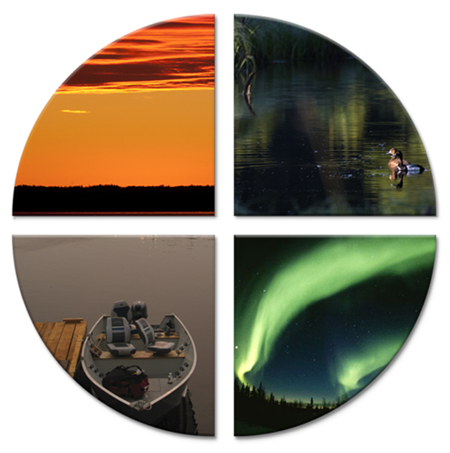

The Westside Economic Development & Investment Attraction Committee
is proud to present the
3rd Annual Westside Economic Development
& Investment Attraction Conference

May 26 - 28, 2020
Sandy Beach Resort, Saskatchewan
Northern Village of Beauval, Saskatchewan
Northern Regions 2 & 3

The Symposium will bring together the region’s existing tourism businesses and aspiring indigenous youth
with leaders in Indigenous Tourism to examine ways to showcase the cultural traditions of the Westside
and gain insights into experiential tourism in order to secure a path for the region (The Westside)
to participate in the SK Indigenous tourism sector.

Westside Economic Development & Business Attraction Conference
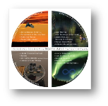
May 26 - 28, 2020, Sandy Beach Resort, SK
Northern Village of Beauval, Saskatchewan, Northern Regions 2 & 3

SPONSORSHIP LEVELS
Churchill River ($10,000)
- Spotlight on Agenda – opportunity for Sponsor to address attendees with 5 minute presentation
- Logo prominently displayed on conference venue signage.
- One general session “thank-you” announcement from Forum Emcee
- Logo & listing on Forum webpage
- Forum Participant Kit - insert handouts (optional)
- Trade Show Booth Space
- Four (4) Symposium registrants
Beaver River ($5,000)
- Logo displayed on conference venue signage.
- One general session “thank-you” announcement from Forum Emcee
- Logo & listing on Forum webpage
- Forum Participant Kit - insert handouts (optional)
- Trade Show Booth Space
- Two (2) Forum tickets
Canoe River ($2,500)
- Logo displayed on conference venue signage.
- One general session “thank-you” announcement from Forum Emcee
- Logo & listing on Symposium webpage
- Trade Show Booth Space
- One (1) Forum ticket
Waterhen River ($1,000)
- Logo displayed on conference venue signage.
- One general session “thank-you” announcement from Forum Emcee
- Trade Show Booth Space
- Logo & listing on Forum webpage
Cowan River ($500)
- Logo displayed on conference venue signage.
- Logo & listing on Forum webpage
Clearwater River ($250)
- Logo displayed on conference venue signage.
- Logo & listing on Forum webpage
VENUE Sponsor Opportunities
2 – Breakfast $ 1,250 ea.
4 - Health Break $ 625 ea.
2 - Lunch Buffet $ 1,875 ea.

Westside Economic Development & Business Attraction Conference
May 26 - 28, 2020, Sandy Beach Resort, SK
Northern Village of Beauval, Saskatchewan, Northern Regions 2 & 3

SPONSORSHIP REGISTRATION

Company/Organization: _______________________________________________________________
(Please print clearly – this is how it will appear on print materials.)

Contact Name: ______________________________________________________________________

Position/Title: ________________________________________________________________________

Mailing Address: _____________________________________________________________________

City: ________________________________________________ Province/Territory: _______________

Work #: _______________________ Fax #: ______________________ Alt. #: ___________________

Email Address: ______________________________________________________________________

Cheques Payable to:
Northwest Communities Management Company Ltd. Box 479 Beauval, SK S0M 0G0

Questions? Visit: www.westsidetourism.ca.
Contact: Celine Favreau, Conference Project Coordinator
Email: celine@ctfavreau.com
Phone: 306.250.7345

Please select your sponsorship commitment:
_____ Churchill River ($10,000)
_____ Beaver River ($5,000)
_____ Canoe River ($2,500) VENUE SPONSOR:
_____ Waterhen River ($1,000) _____ 2 – Breakfast $ 1,250 ea.
_____ Cowan River ($500) _____ 4 - Health Break $ 625 ea.
_____ Clearwater River ($250) _____ 2 - Lunch Buffet $ 1,875 ea.

Total Sponsorship Commitment: ___________________ Trade Show Booth Space: Yes_______ No________

Thank-You for Your Support!

